The Report describes about the model performance:

As we know that the classes are Bus, Cars, LCV, M2W, MAV, Rickshaw and Truck. The model has to be trained on the given classes.

**Confusion Matrix:** The confusion matrix tells us how precise the model is about that class.

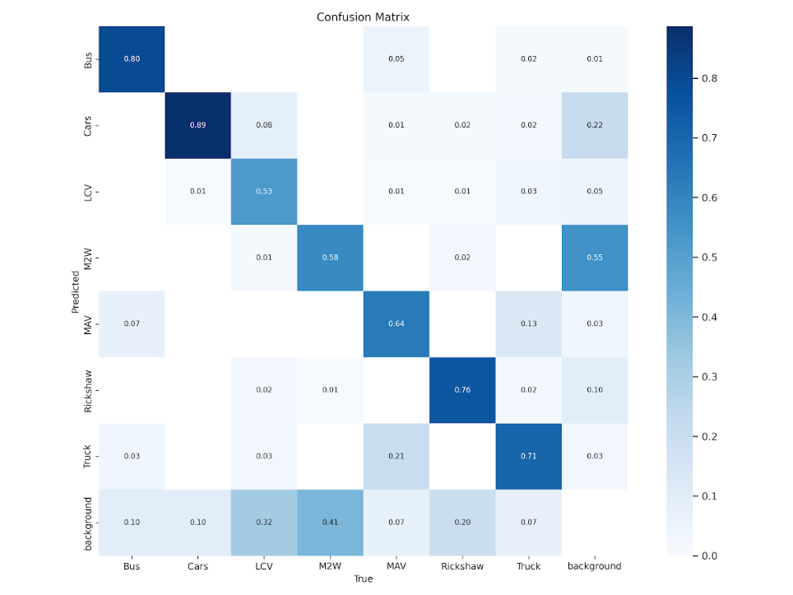

After seeing the confusion matrix we can see that the model is more precise about the Bus, Cars, LCV, MAV, Rickshaw and Truck. But when we go through the matrix the M2W is not precise we see that the confidence value is less. The background is created because When there's no object in a region, the class with the highest probability is often considered the background class. By seeing the confusion matrix we can say that the model is more accurate on cars, bus. Secondly the rickshaw and truck are having the confidence over 70% which is decent but need to improve. And coming to the point the M2W and LCV is having less confidence and mixing with the background. So the model have to gain accuracy in M2W and LCV.

**P_Curve:** The P_Curve Shows how the precision is changing with the Confidence value.

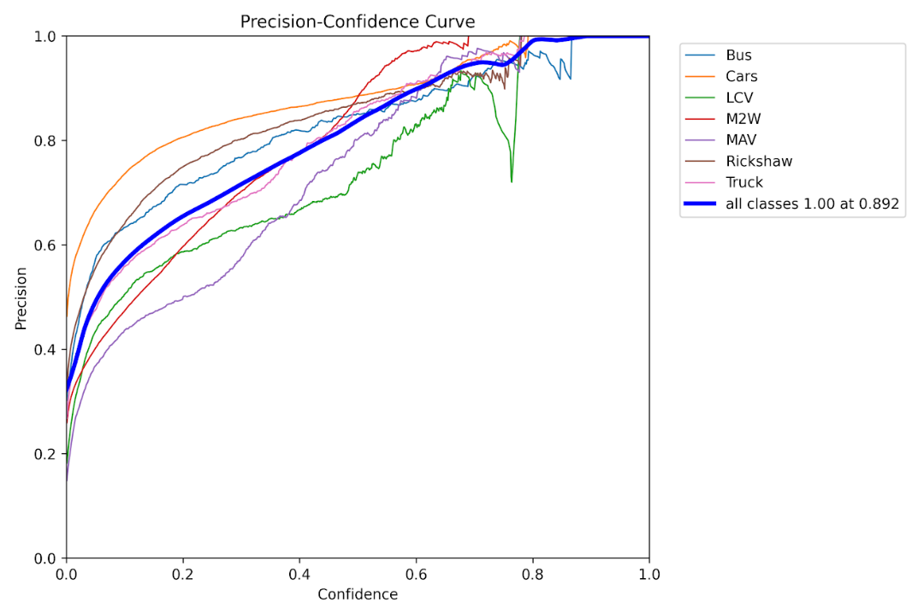

In the graph we can see that the precision is increasing with confidence but coming to the M2W and LCV lags behind the other classes and apart from these 2 classes we can see that MAW is also lagging somewhat behind the other classes.

**Precision and Recall Curve:** The Precision Recall curve indicates the ratio of true positive predictions to the actual positives in the dataset. So by analyzing the image we can say that all classes are predicted positively so that the mAP@0.5(mean average precision about IOU 0.5.) is 0.736 and as we discussed earlier the 2 classes are not having either good precision or recall. Due to that two classes the model is lagging back to predict the vehicles of the respected classes.

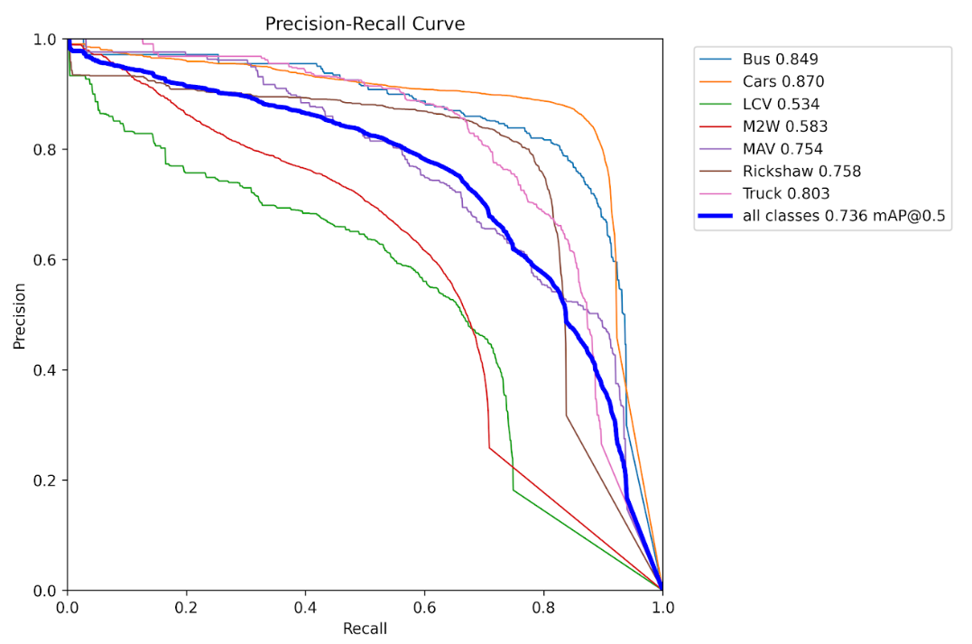

**Results:** The Results show the loss after iterating through the 10 epochs.

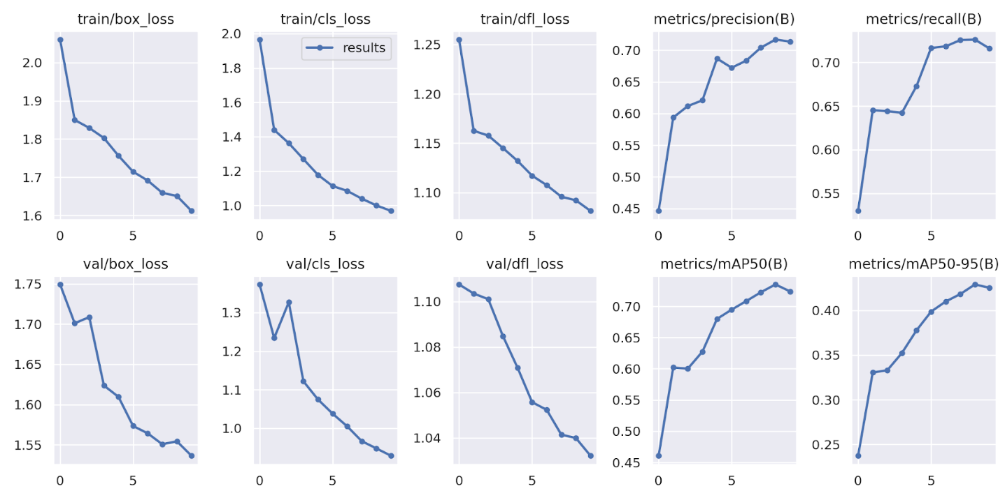

Compared to last time the loss is quite decent. The number of epochs were 10 that are performing good enough and we can use the methods like the early stopping, and keeping the checkpoints so that we will store the best model with good accuracy.

**Testing on a video:**

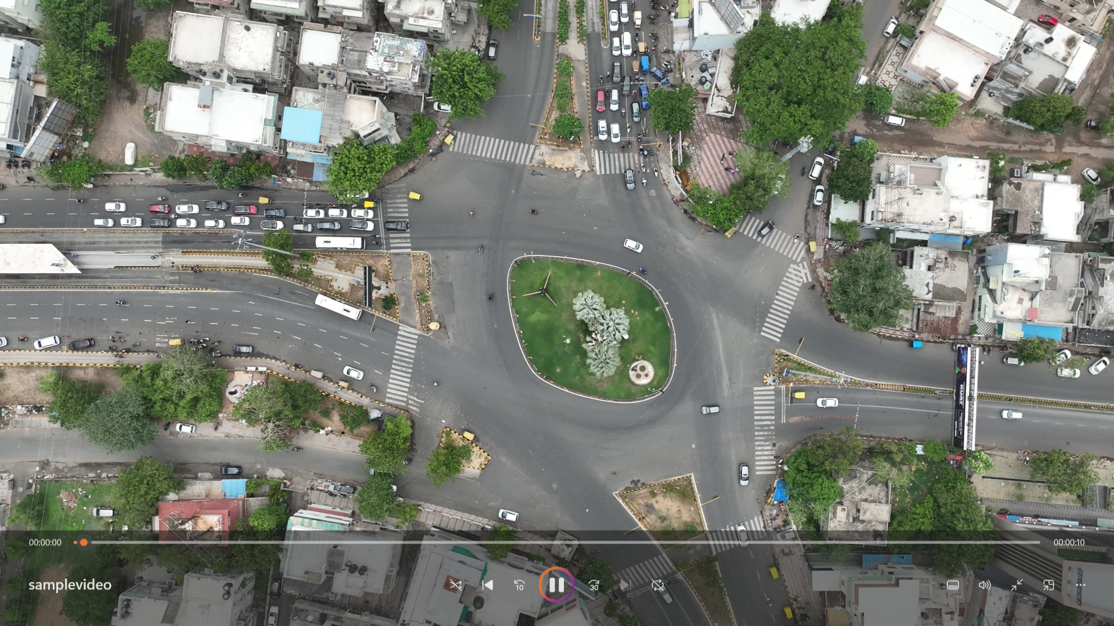

This is the sample video which we are considering.

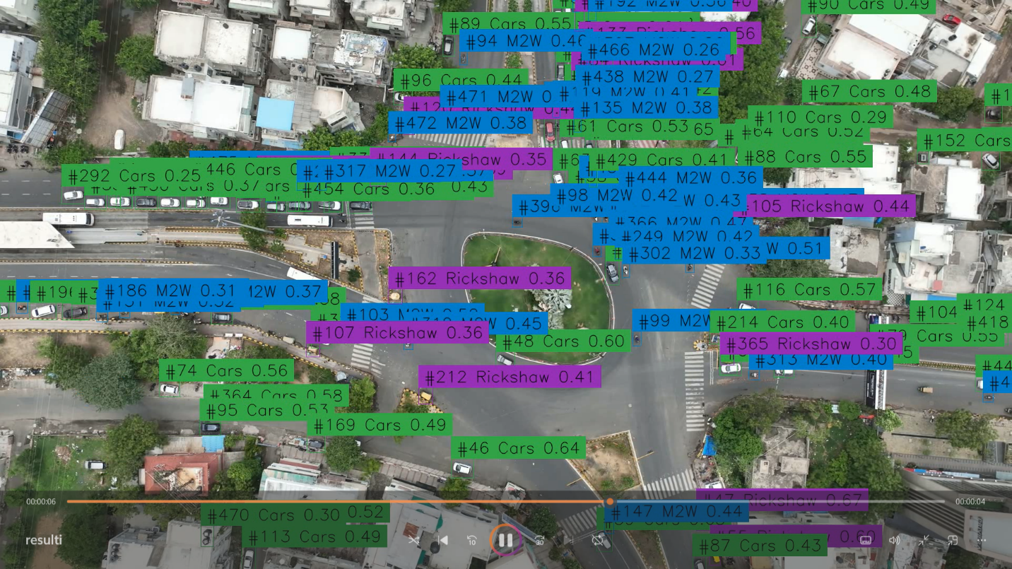

And the output is like this.

**Conclusion:**

The model's performance evaluation reveals that the model effectively classifies most vehicles (Bus, Cars, LCV, MAV, Rickshaw, and Truck) with good precision, indicating successful recognition of these classes. However, the M2W class exhibits lower precision, suggesting challenges in accurate identification, possibly due to class-specific complexities or non-annotated data. And LCV class also exists here which indicates instances where the model struggles to assign a class confidently, leading to misclassifications. Precision generally improves with higher confidence levels, yet the M2W class and LCV class continue to lag behind. The Precision-Recall curve indicates relatively balanced predictions for most classes, resulting in a mean average precision (mAP@0.5) of 0.736. Training process optimization, including more epochs, could further enhance the model's learning and generalization. Video testing was conducted and the output obtained signifies that there are still some vehicles (LCV) that are not correctly recognised.  
  
While the model demonstrated good performance on several vehicle classes, there are clear challenges with the M2W class and the LCV class. To address these challenges and enhance overall performance, potential actions including retraining the model with more M2W-specific data or checking the existing training data for correct annotation and refining the LCV class handling can be done. Further optimization of the training process, potentially with more epochs, could also be explored. To make the model learn better, it's a good idea to do more rounds of training. This helps the model get really good at understanding things and reduces the mistakes it makes. It's like practicing a lot to become really skilled at something. And when the model gets better, its performance becomes smoother.